Year Six
Talbot Primary School



Welcome Back!

Some of you have not been to school for a long time.
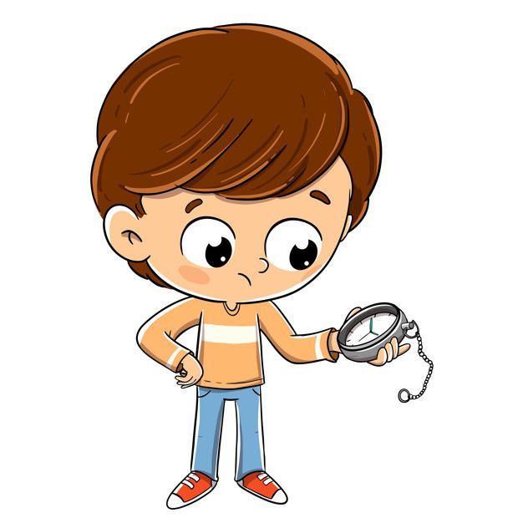
We’ve been waiting to see you again!
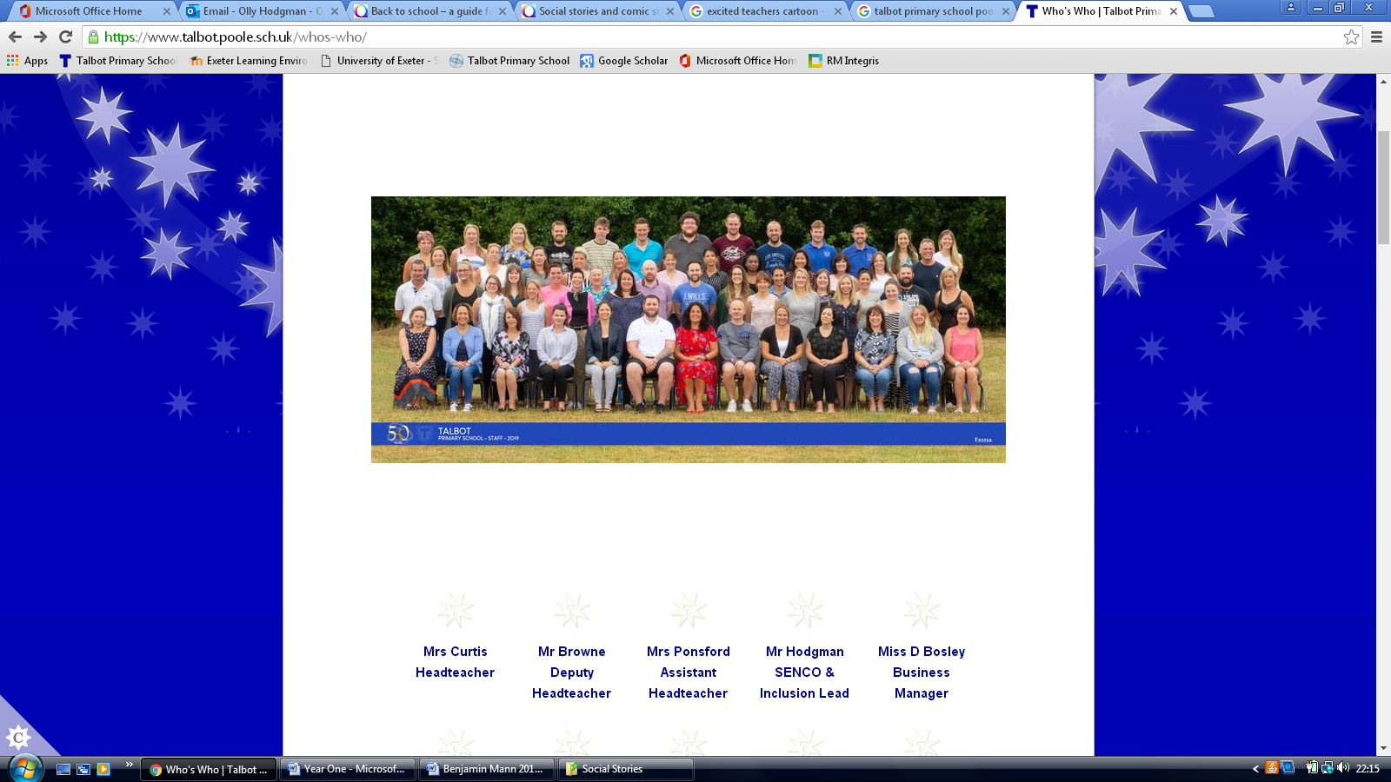
While a few things might look a bit different:
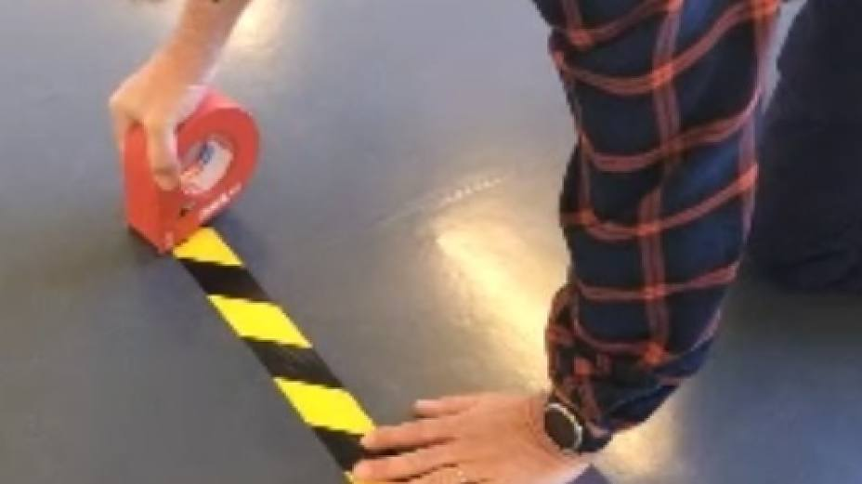
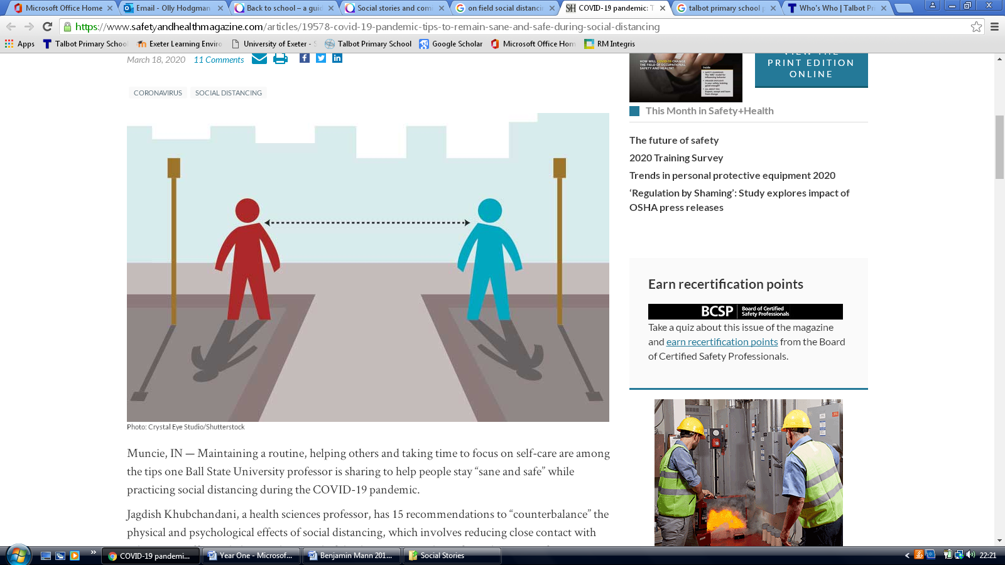
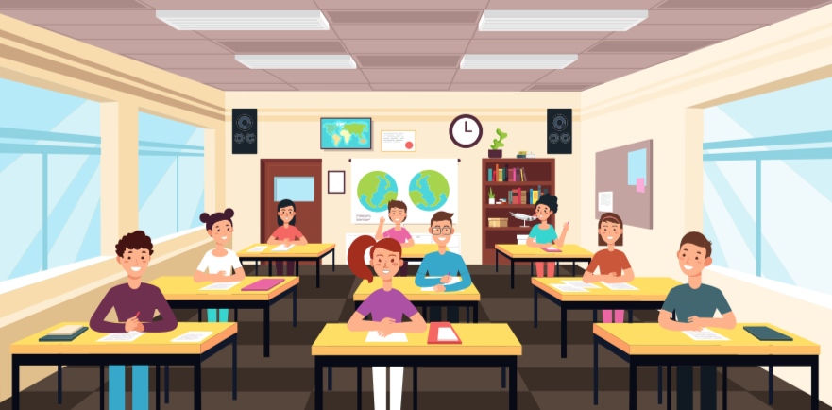
Some things haven’t changed!
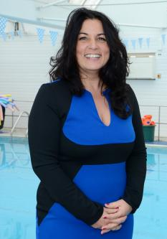
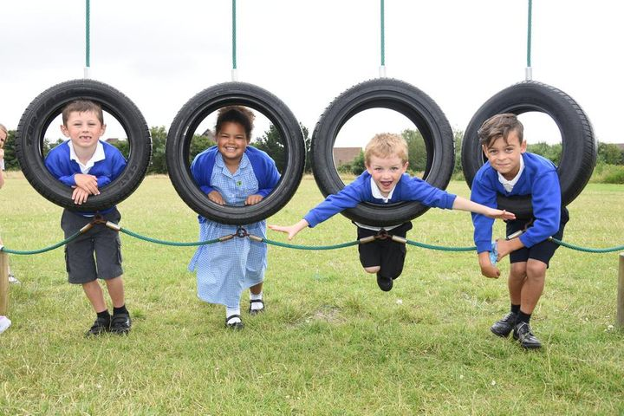
Soon, all of you will be able to come back into school:



You’ll get to see your class teacher on the first morning back with your class.

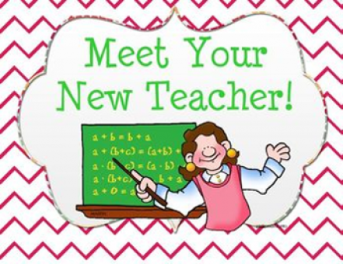
Before meeting your new teacher later that day.
Exciting!
Your classroom will be here:

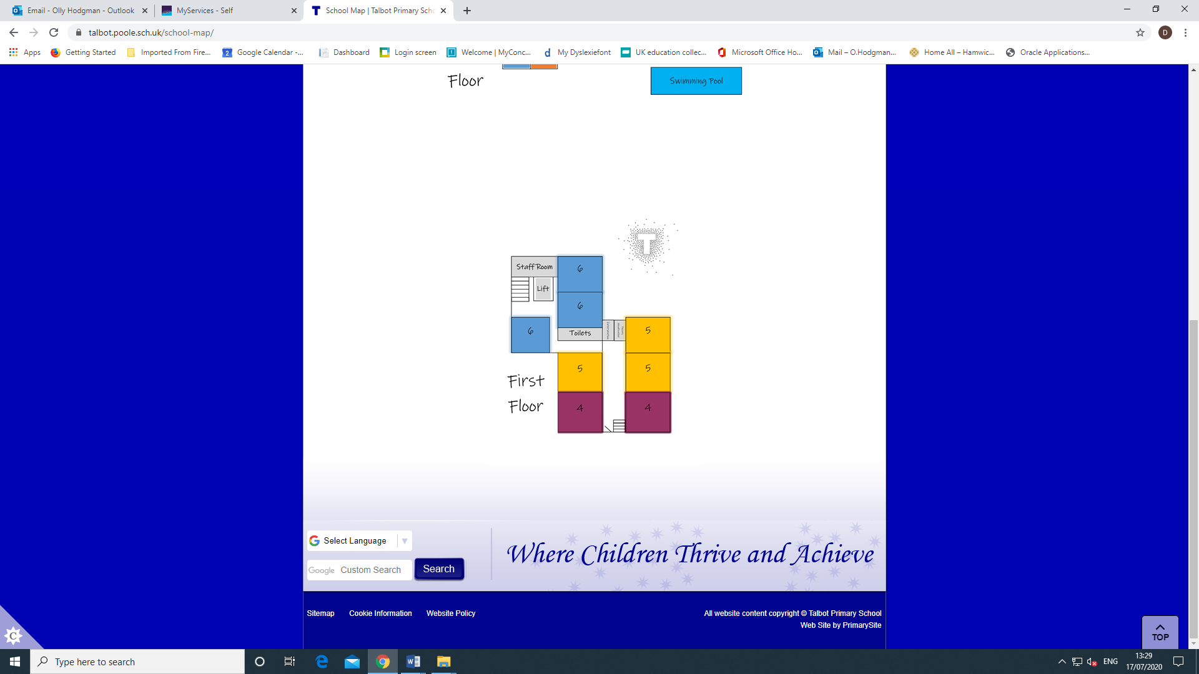

You’ll keep your bag and coat in your own locker

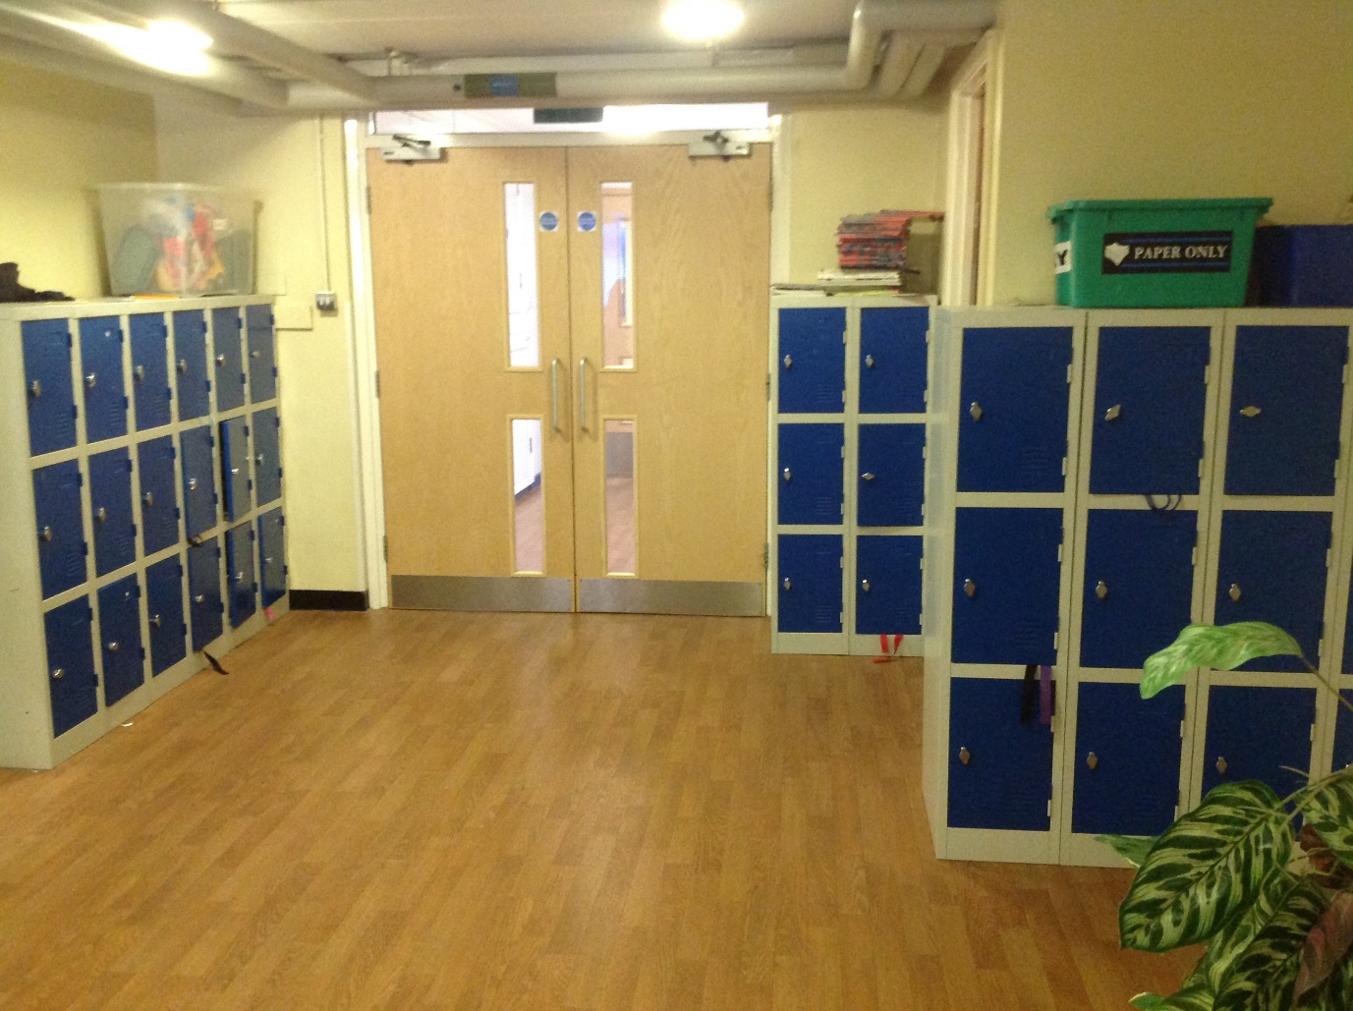

You’ll soon know your way around.
Have a great summer, and we look forward to seeing you in September!

